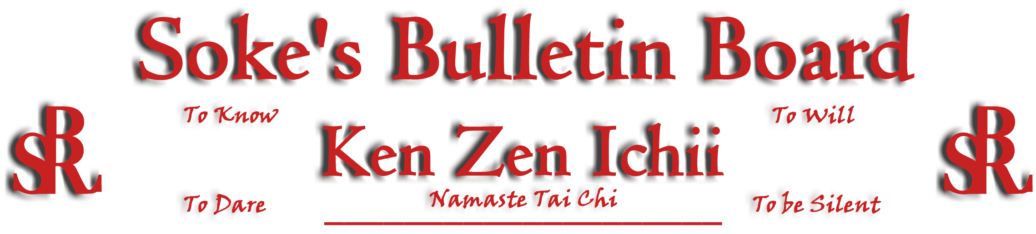
www.kenzenichii.com

October 2010
Promotions
House of Soke
Congratulations to Sensei Gloria Baker on the promotion to the rank of Shihan
Congratulations to Sensei Scott Dellinger on the promotion to the rank of Shihan.
Congratulations to Sensei Sue LaFond on the promotion to the rank on Yodan

House of Soke II
Congratulations to Marilyn Kelly on earning the rank of Brown Belt
Congratulations to Grant Corbett on earning the rank of Yellow Belt
Congratulations to Alexandra Corbett on earning the rank of Yellow Belt

House of Soke
Congratulations to Shihan Gloria Baker on her October 3rd promotion and to Shihan Scott Dellinger and Sensei Sue LaFond on their October 10th promotions.

On behalf of all in the system that Kyoshi Leary has assisted, including myself, thank you. He is a true Renaissance Man.

The new Tai Chi DVD is essential to every aspect of martial arts. Copies will be available at the October 10th Black Belt Test at the House of Soke or can be purchased online by contacting Kyoshi Leary at the House of Soke II, Kzihos2@gmail.com, 704-947-2522.

House of Soke II
On Oct. 10, 2010 Eric Calvert and Jake Carpenter will be taking their Black Belt Test. Please come and support Eric Calvert and Jake Carpenter as they embark on their “Right of Passage”. If you plan to attend or have any questions, please contact Sensei John Casisa at casisa@mindspring.com.

A Black Belt dinner will be held on Saturday, October 9th beginning at 6 pm at the Acropolis Cafe & Grille in Cornelius. This dinner is an opportunity for the Black Belts and spouses to get together, especially with those coming in from out of town, and affords a chance for socialization outside of the dojo. If you are interested in participating, please RSVP so Sensei John Casisa at casisa@mindspring.com.

Welcome new students Aiden Dean, Jon Dean, Cooper Bright, Heather Hancock, and Jimmy Pierce.

Sensei Bullock will do a Self-Defense Demo for Premier Inc. Family Wellness Day. The demo will be held at the Ballantyne Brixham Green Tent on October 17th from 12 noon to 4pm - http://www.go-ballantyne.com/LinkClick.aspx?fileticket=9gkocIkbI68%3d&tabid=114&mid=559. All Ken Zen Ichii students are encouraged to attend and show support . Please contact Sensei Bullock if you plan to attend at trenton.bullock@fusemail.com.
KZI - Tennessee
Welcome to new student Christy O'Brien.

Sapphire Dragons
All is well at the Sapphire Dragons.

KZI NEWSLETTER – October 2010
Page 2 of 2
BSR Modern Martial Arts School
Thank you to all who attended the Open House. We had a great turn-out and special thanks go to Soke Dwight Childress for his participation and dojo gift. Thank you also to Soke Ferell for his visit and all his support.

Welcome new students Mike York and Missy York.

Congratulations Shihan Baker from all of us at BSRMMA, OUS!

Crush Fitness
Black Belt tests are scheduled for Pierson Bisceglia on October 17th and for Demi Bozas on November 7th.

There will be Women's Self Defense Class from 2-5pm on October 9th.

Welcome new student: Tommy Hayward

Our new kid’s karate class started Tuesday, September 27th at 5:30pm

Hudson Valley RyuTe Kan
All is going well.

Video Clip of the Month
Part 2 of the Weapons in Motion video is online. http://www.youtube.com/watch?v=3iUcaCcYmKQ. Please check it out..Sensei Calabrase.

Miscellaneous
Much gratitude and appreciation are extended to all the instructors who have shaped my life, past, present, and future, among them Soke Dwight Childress who has not received the public accolades he deserves and both “Judo” Gene LeBell and Gokor Chivichyan (http://sportsillustrated.cnn.com/2010/writers/josh_gross/08/25/mma.boxer/index.html) …Sensei Scott Dellinger

Pearl’s of Wisdom
To think of winning is sickness. To think only of using the martial arts is sickness. To think only of demonstrating the results of one’s training is sickness, as is thinking only of making an attack or waiting for one. To think in a fixated way only of expelling such sickness is also sickness. Whatever remains absolutely in the mind should be considered sickness. As these various sicknesses are all present in the mind, you must put your mind in order and expel them….To think of expelling sickness is a thought. However, you may expel thought by the use of thought. When you leave off thoughts, you will become void of them. In this way, using thoughts is said to be No-Thought. If you can expel the sickness of any remaining thoughts with thought, afterward both the thought that has been expelled and the thought with which it was expelled will disappear…If you wish to expel sickness, the thought that is used to expel sickness will not remain afterward, and is called…”No-Thought”…[or] “Using an attachment to become nonattached.” Yagyu Munenori, The Death Dealing Sword

Editor’s Notes
Articles for the Ken Zen Ichii website and newsletter are being actively solicited. Anyone who wants to submit an article should contact Sensei Michael Calabrase at mcalabrase@bsrwarriors.com or the editor at Noah_Valle@hotmail.com, (818) 395-0757.

